# expansion_tile_sample

# Android Estudio V3.0.17/Flutter

Objetivo:

F.Creación: 13-4-2018

Programa:

Fuente:

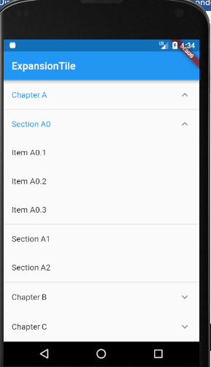

En 2.5 listas esta el mismo ejemplo pero mas simple

**import 'package:flutter/material.dart'**;  
  
**class** ExpansionTileSample **extends** StatelessWidget {  
 @override  
 Widget build(BuildContext context) {  
 **return new** MaterialApp(  
 home: **new** Scaffold(  
 appBar: **new** AppBar(  
 title: **const** Text(**'ExpansionTile'**),  
 ),  
 body: **new** ListView.builder(  
 itemBuilder: (BuildContext context, int index) => **new** EntryItem(data[index]),  
 itemCount: data.**length**,  
 ),  
 ),  
 );  
 }  
}  
  
*// One entry in the multilevel list displayed by this app.***class** Entry {  
 Entry(**this**.**title**, [**this**.**children** = **const** <Entry>[]]);  
 **final** String **title**;  
 **final** List<Entry> **children**;  
}  
  
*// The entire multilevel list displayed by this app.***final** List<Entry> data = <Entry>[  
 **new** Entry(**'Chapter A'**,  
 <Entry>[  
 **new** Entry(**'Section A0'**,  
 <Entry>[  
 **new** Entry(**'Item A0.1'**),  
 **new** Entry(**'Item A0.2'**),  
 **new** Entry(**'Item A0.3'**),  
 ],  
 ),  
 **new** Entry(**'Section A1'**),  
 **new** Entry(**'Section A2'**),  
 ],  
 ),  
 **new** Entry(**'Chapter B'**,  
 <Entry>[  
 **new** Entry(**'Section B0'**),  
 **new** Entry(**'Section B1'**),  
 ],  
 ),  
 **new** Entry(**'Chapter C'**,  
 <Entry>[  
 **new** Entry(**'Section C0'**),  
 **new** Entry(**'Section C1'**),  
 **new** Entry(**'Section C2'**,  
 <Entry>[  
 **new** Entry(**'Item C2.0'**),  
 **new** Entry(**'Item C2.1'**),  
 **new** Entry(**'Item C2.2'**),  
 **new** Entry(**'Item C2.3'**),  
 ],  
 ),  
 ],  
 ),  
];  
  
*// Displays one Entry. If the entry has children then it's displayed  
// with an ExpansionTile.***class** EntryItem **extends** StatelessWidget {  
 **const** EntryItem(**this**.**entry**);  
  
 **final** Entry **entry**;  
  
 Widget _buildTiles(Entry root) {  
 **if** (root.**children**.**isEmpty**)  
 **return new** ListTile(title: **new** Text(root.**title**));  
 **return new** ExpansionTile(  
 key: **new** PageStorageKey<Entry>(root),  
 title: **new** Text(root.**title**),  
 children: root.**children**.map(_buildTiles).toList(),  
 );  
 }  
  
 @override  
 Widget build(BuildContext context) {  
 **return** _buildTiles(**entry**);  
 }  
}  
  
**void** main() {  
 runApp(**new** ExpansionTileSample());  
}  
  
*/*  
Sample Catalog  
  
Title: ExpansionTile  
  
Summary: An ExpansionTile for building nested lists, with two or more levels.  
  
Description:  
This app displays hierarchical data with ExpansionTiles. Tapping a tile  
expands or collapses the view of its children. When a tile is collapsed  
its children are disposed so that the widget footprint of the list only  
reflects what's visible.  
  
When displayed within a scrollable that creates its list items lazily,  
like a scrollable list created with `ListView.builder()`, ExpansionTiles  
can be quite efficient, particularly for material design "expand/collapse"  
lists.  
  
  
Classes: ExpansionTile, ListView  
  
Sample: ExpansionTileSample  
  
See also:  
 - The "expand/collapse" part of the material design specification:  
 <https://material.io/guidelines/components/lists-controls.html#lists-controls-types-of-list-controls>  
*/*